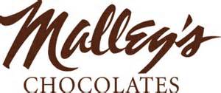
A Sweet Treat For The Whole Family!!!
Come Support The Avon Lake Preschool PTA While Eating Ice Cream and Spending Time with New and Old Friends!
Sunday November 2nd, 2014
5pm-8pm
Bay Village Malley’s Ice Cream Parlor
590 Dover Center Rd
*Bring This Flyer and Turn in When Paying Your Bill-20% Of The Proceeds Go To The ALECPTA*

A Sweet Treat For The Whole Family!!!
Come Support The Avon Lake Preschool PTA While Eating Ice Cream and Spending Time with New and Old Friends!
Sunday November 2nd, 2014
5pm-8pm
Bay Village Malley’s Ice Cream Parlor
590 Dover Center Rd
*Bring This Flyer and Turn in When Paying Your Bill-20% Of The Proceeds Go To The ALECPTA*

